A CRM APPLICATION TO MANAGE THE BOOKING OF CO-LIVING

by Sireesha Palli

[214g1a05a1@srit.ac.in](mailto:214g1a05a1@srit.ac.in)

ABSTRACT

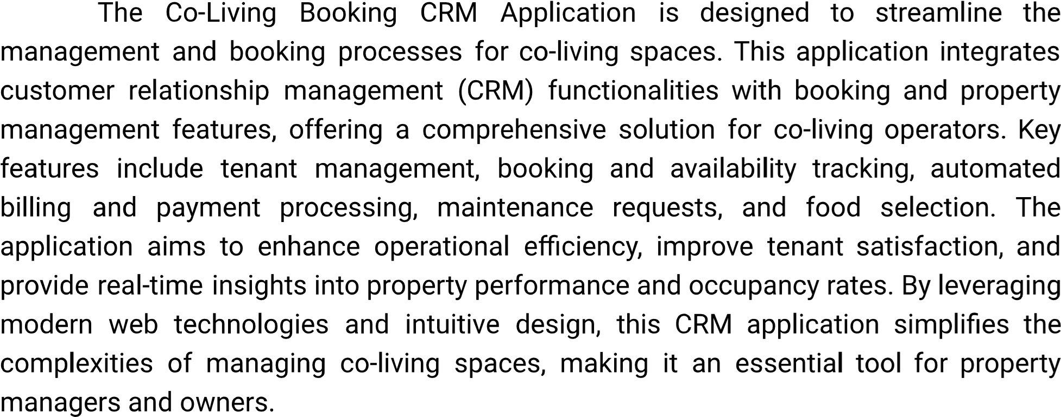

|  |  |  |
| --- | --- | --- |
|  | **INDEX PAGE** |  |
| **Topics**  1.Salesforce |  | **Page N0**  01 |
| 2.Objects |  | 02-03 |
| 3.Tabs |  | 04-05 |
| 4.The Lightning App |  | 06 |
| 5.Fields and Relationship |  | 07 |
| 6.Validation rules |  | 08 |
| 7.Profile |  | 09 |
| 8.Roles |  | 10 |
| 9.Users |  | 11 |
| 10.User Adoption |  | 12-13 |
| 11.Reports |  | 14 |
| 12.Dashboards |  | 15 |
| 13.Flows |  | 16-20 |

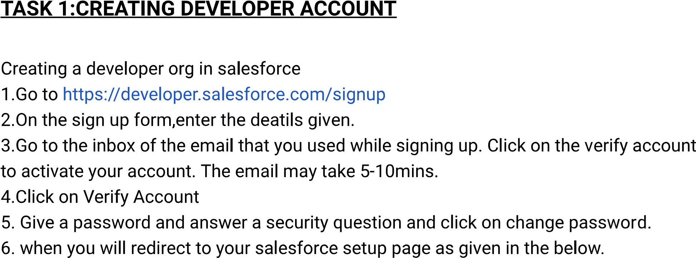

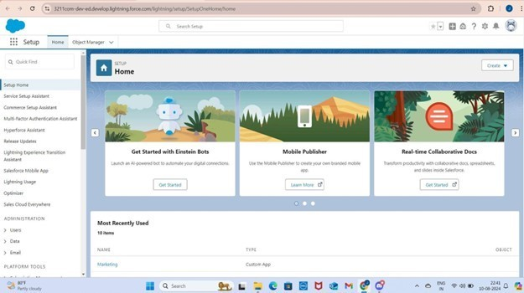

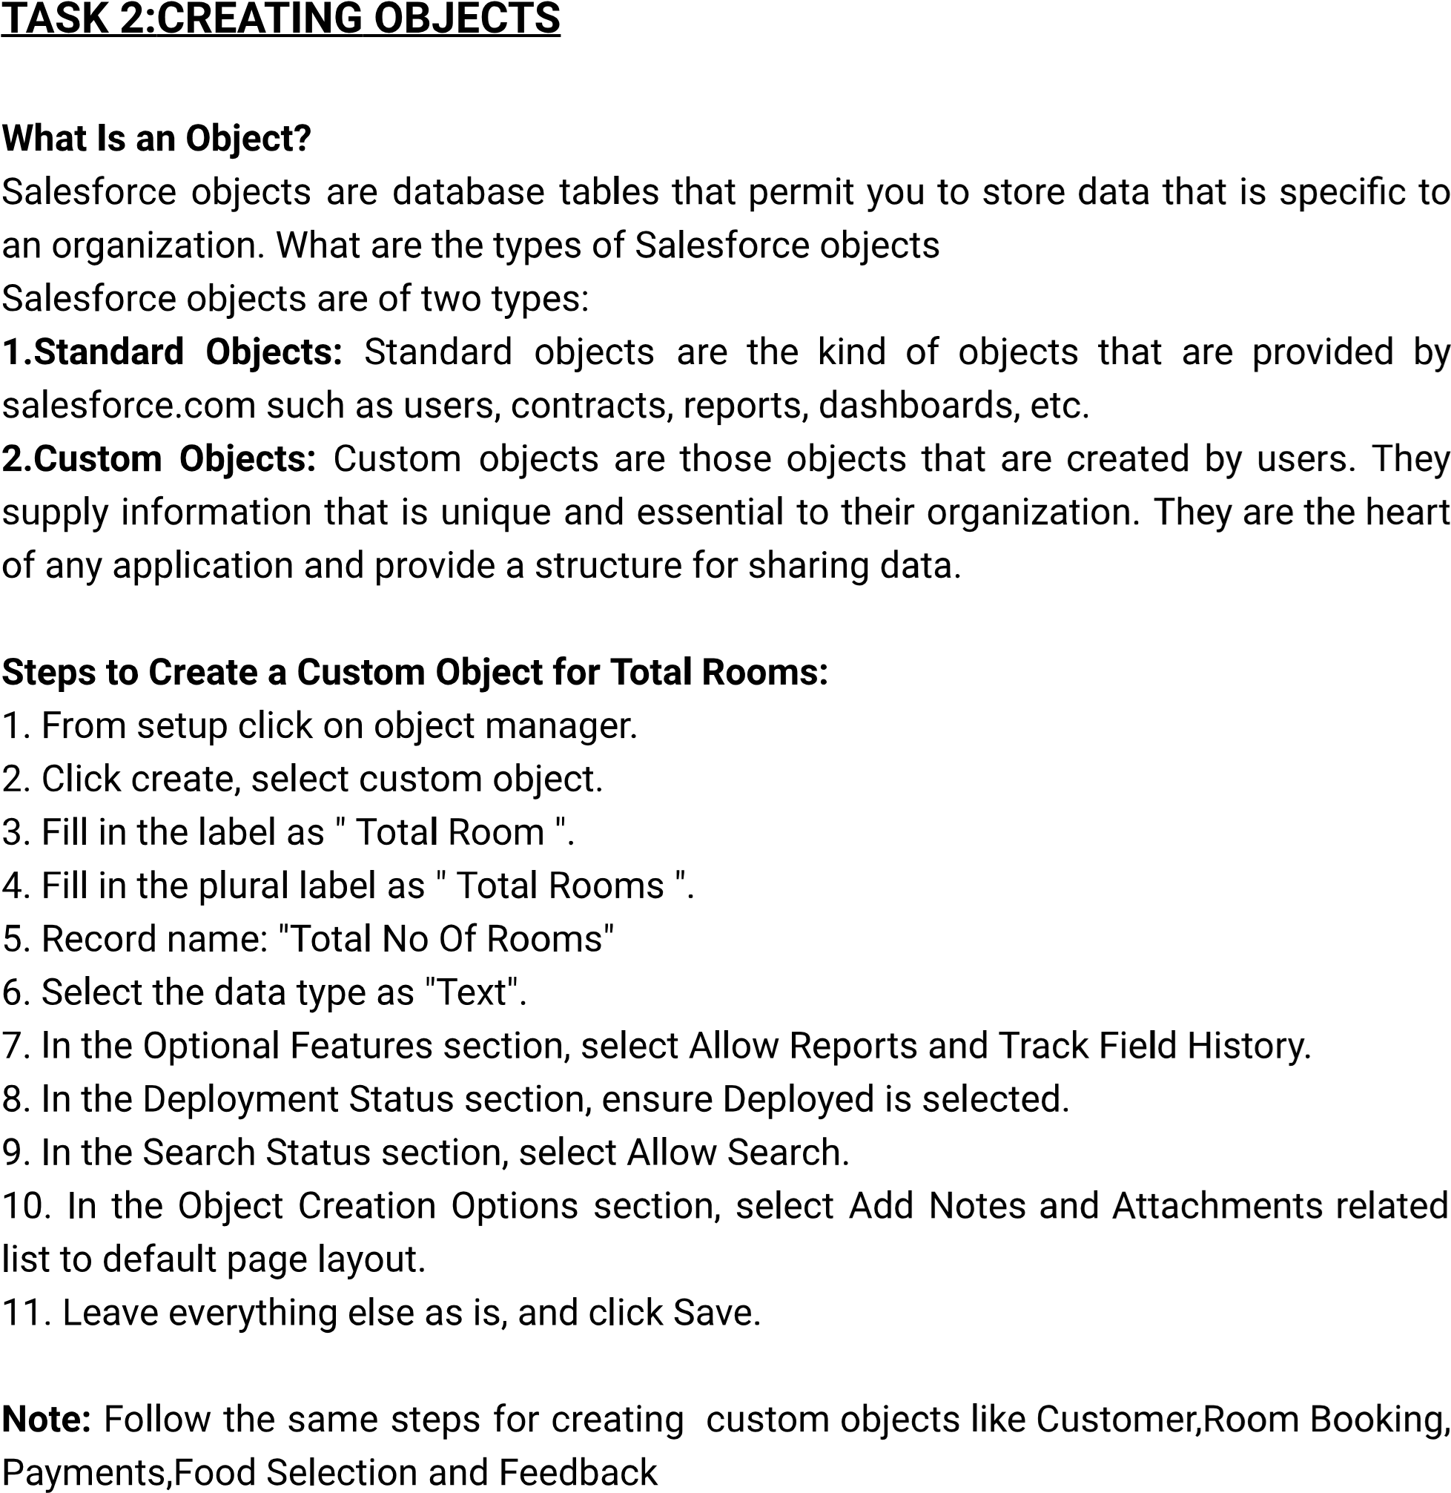

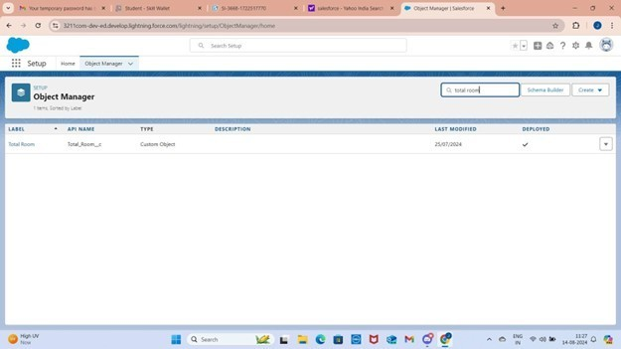

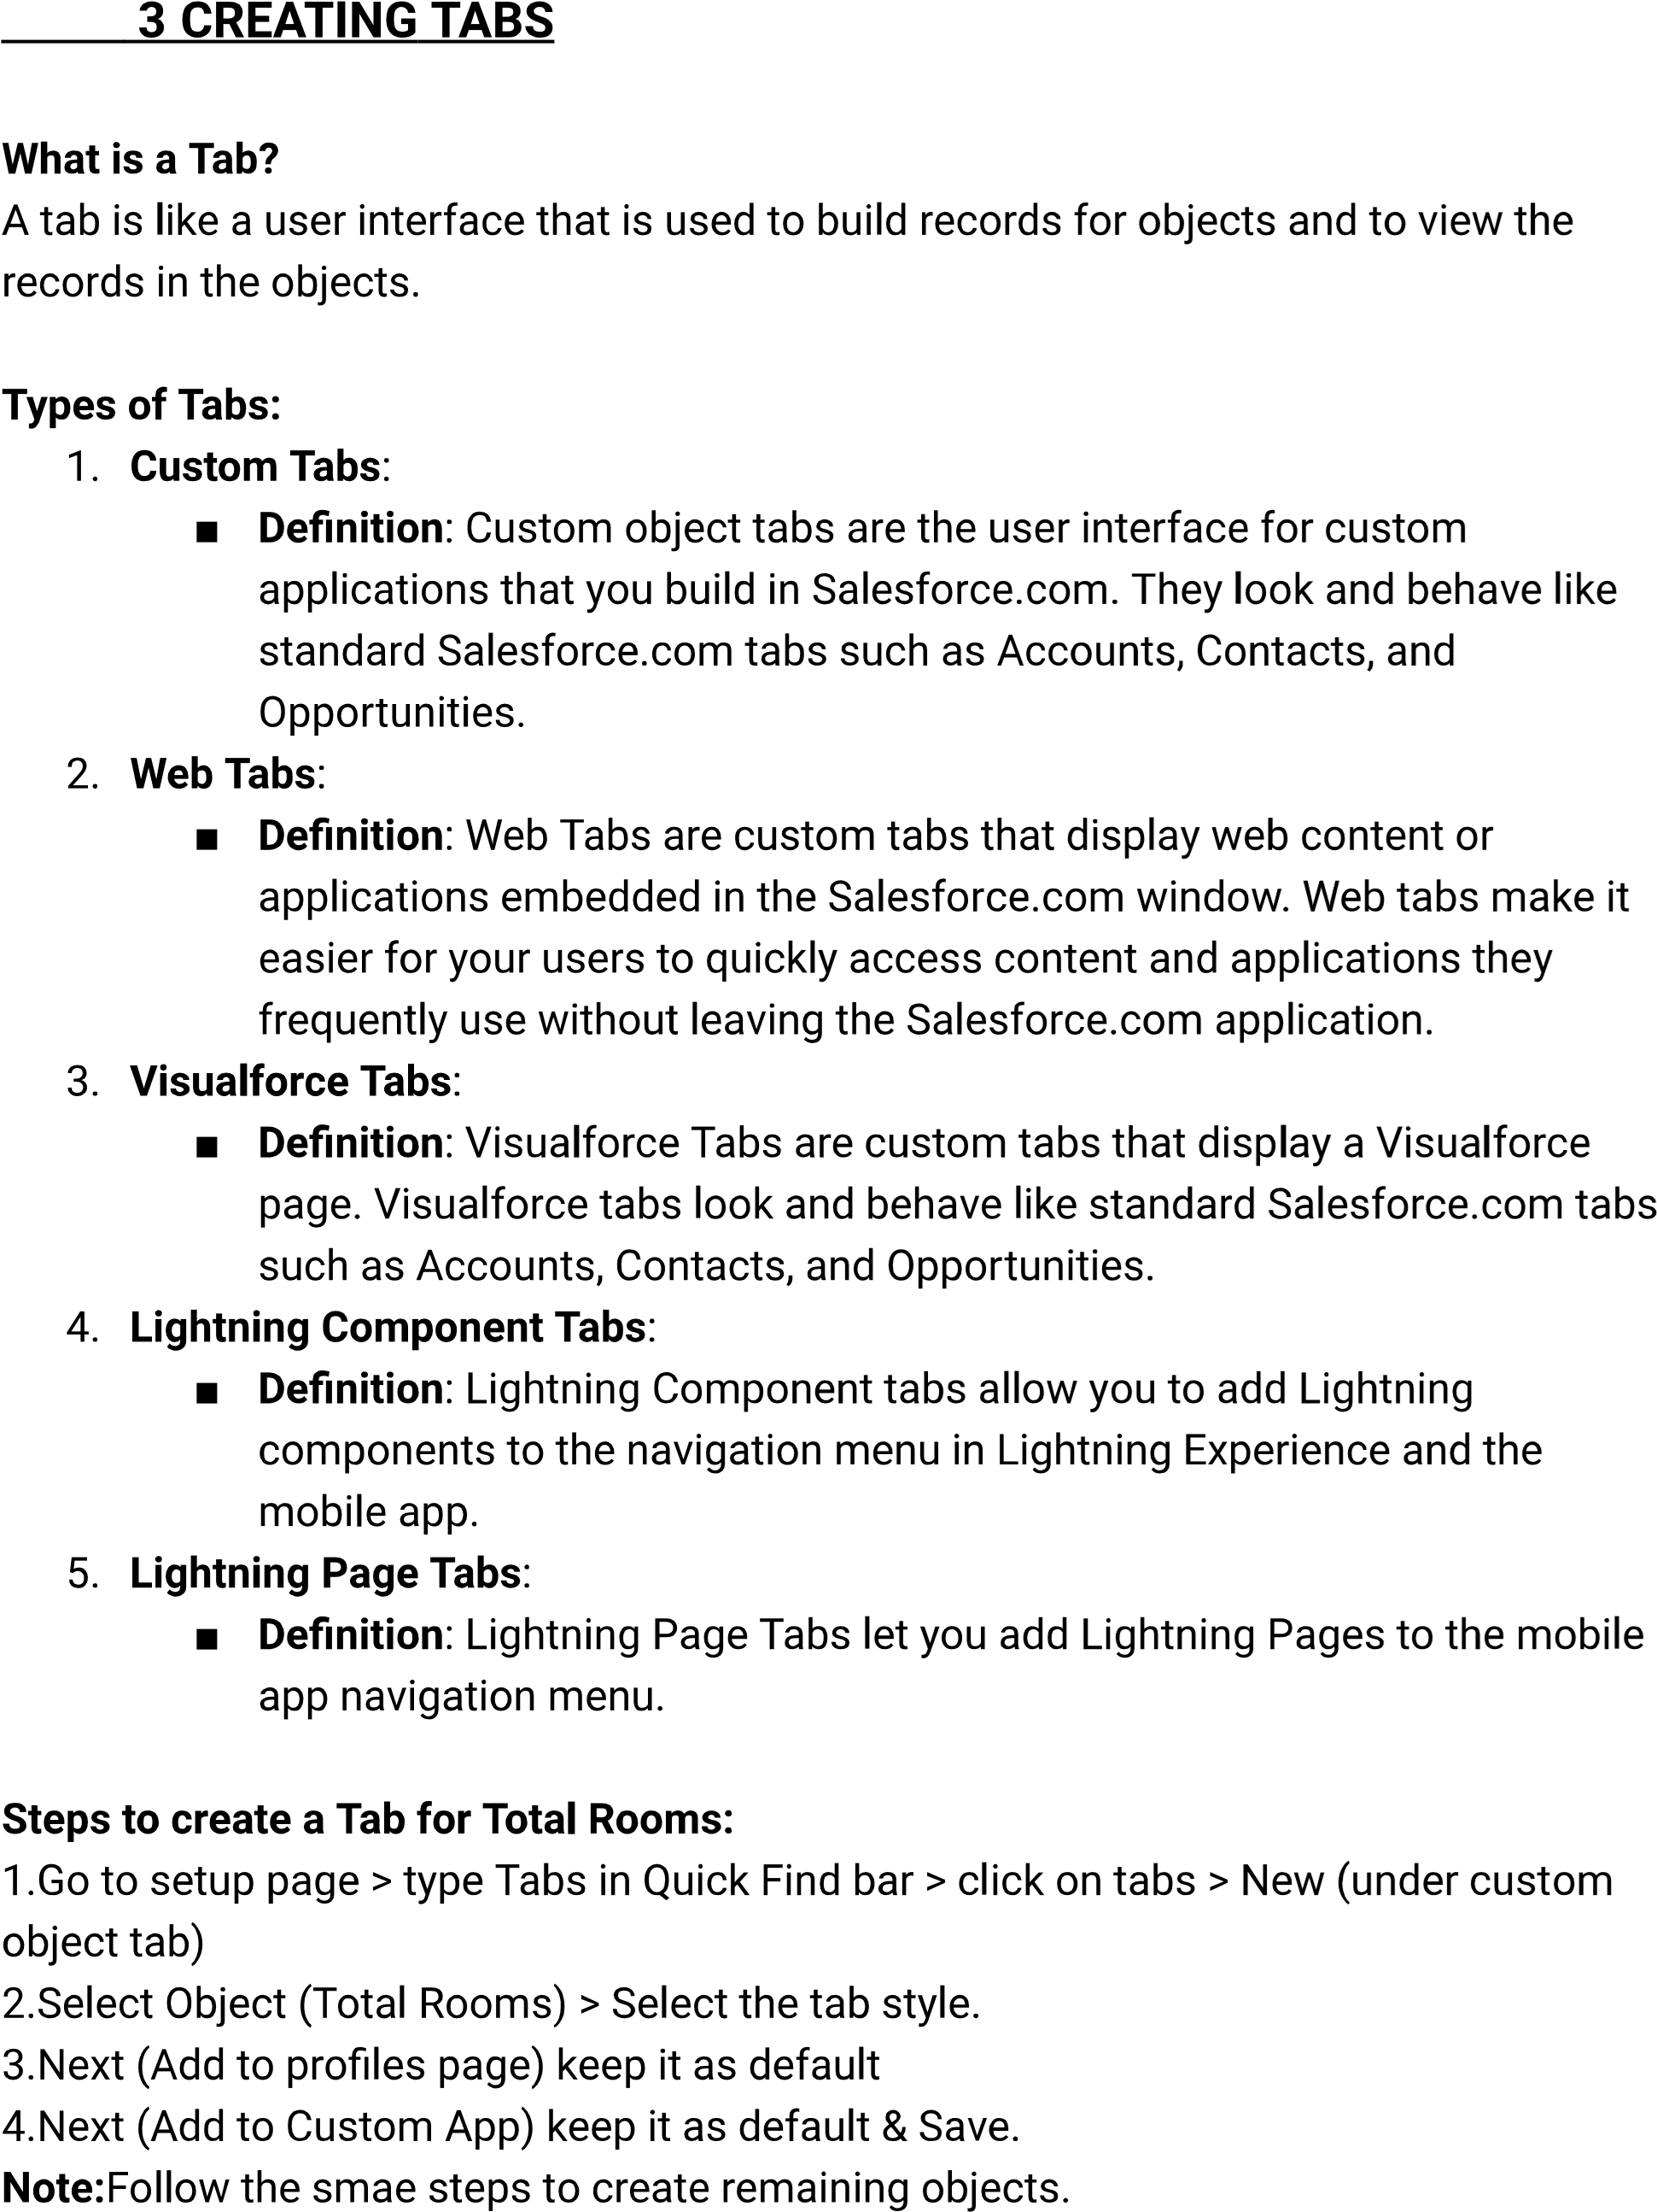

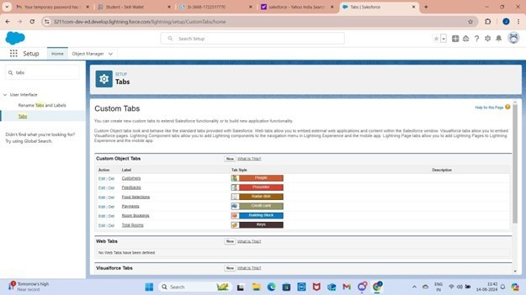

1. **CREATING LIGHTNING APP**

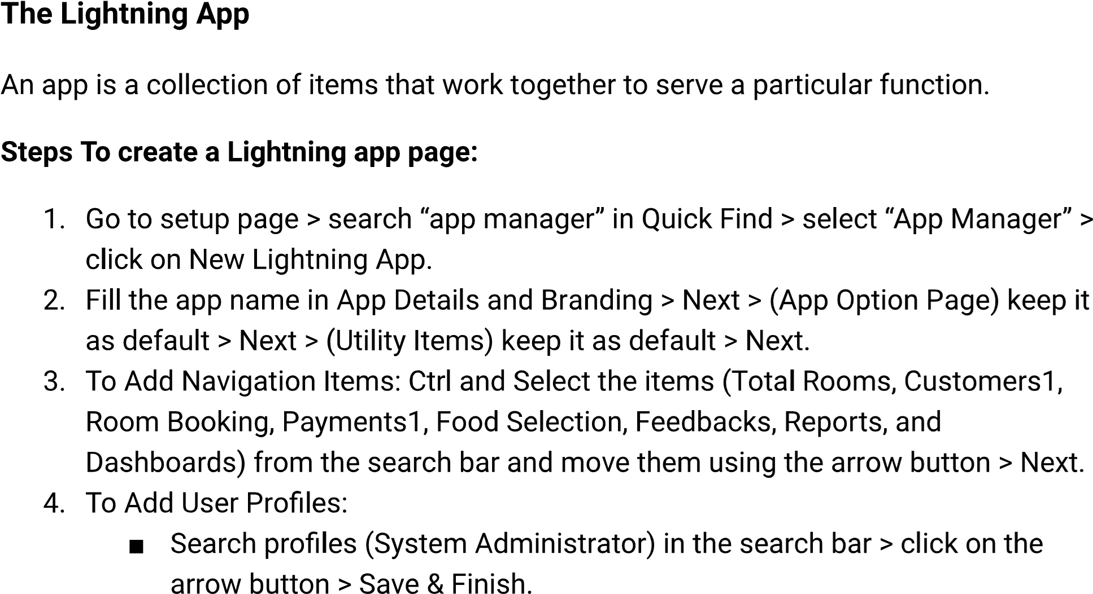

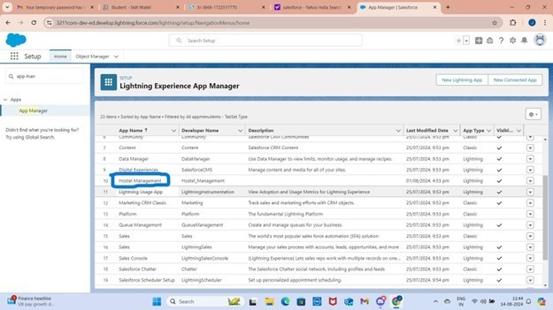

1. **FIELDS & RELATIONSHIPS**

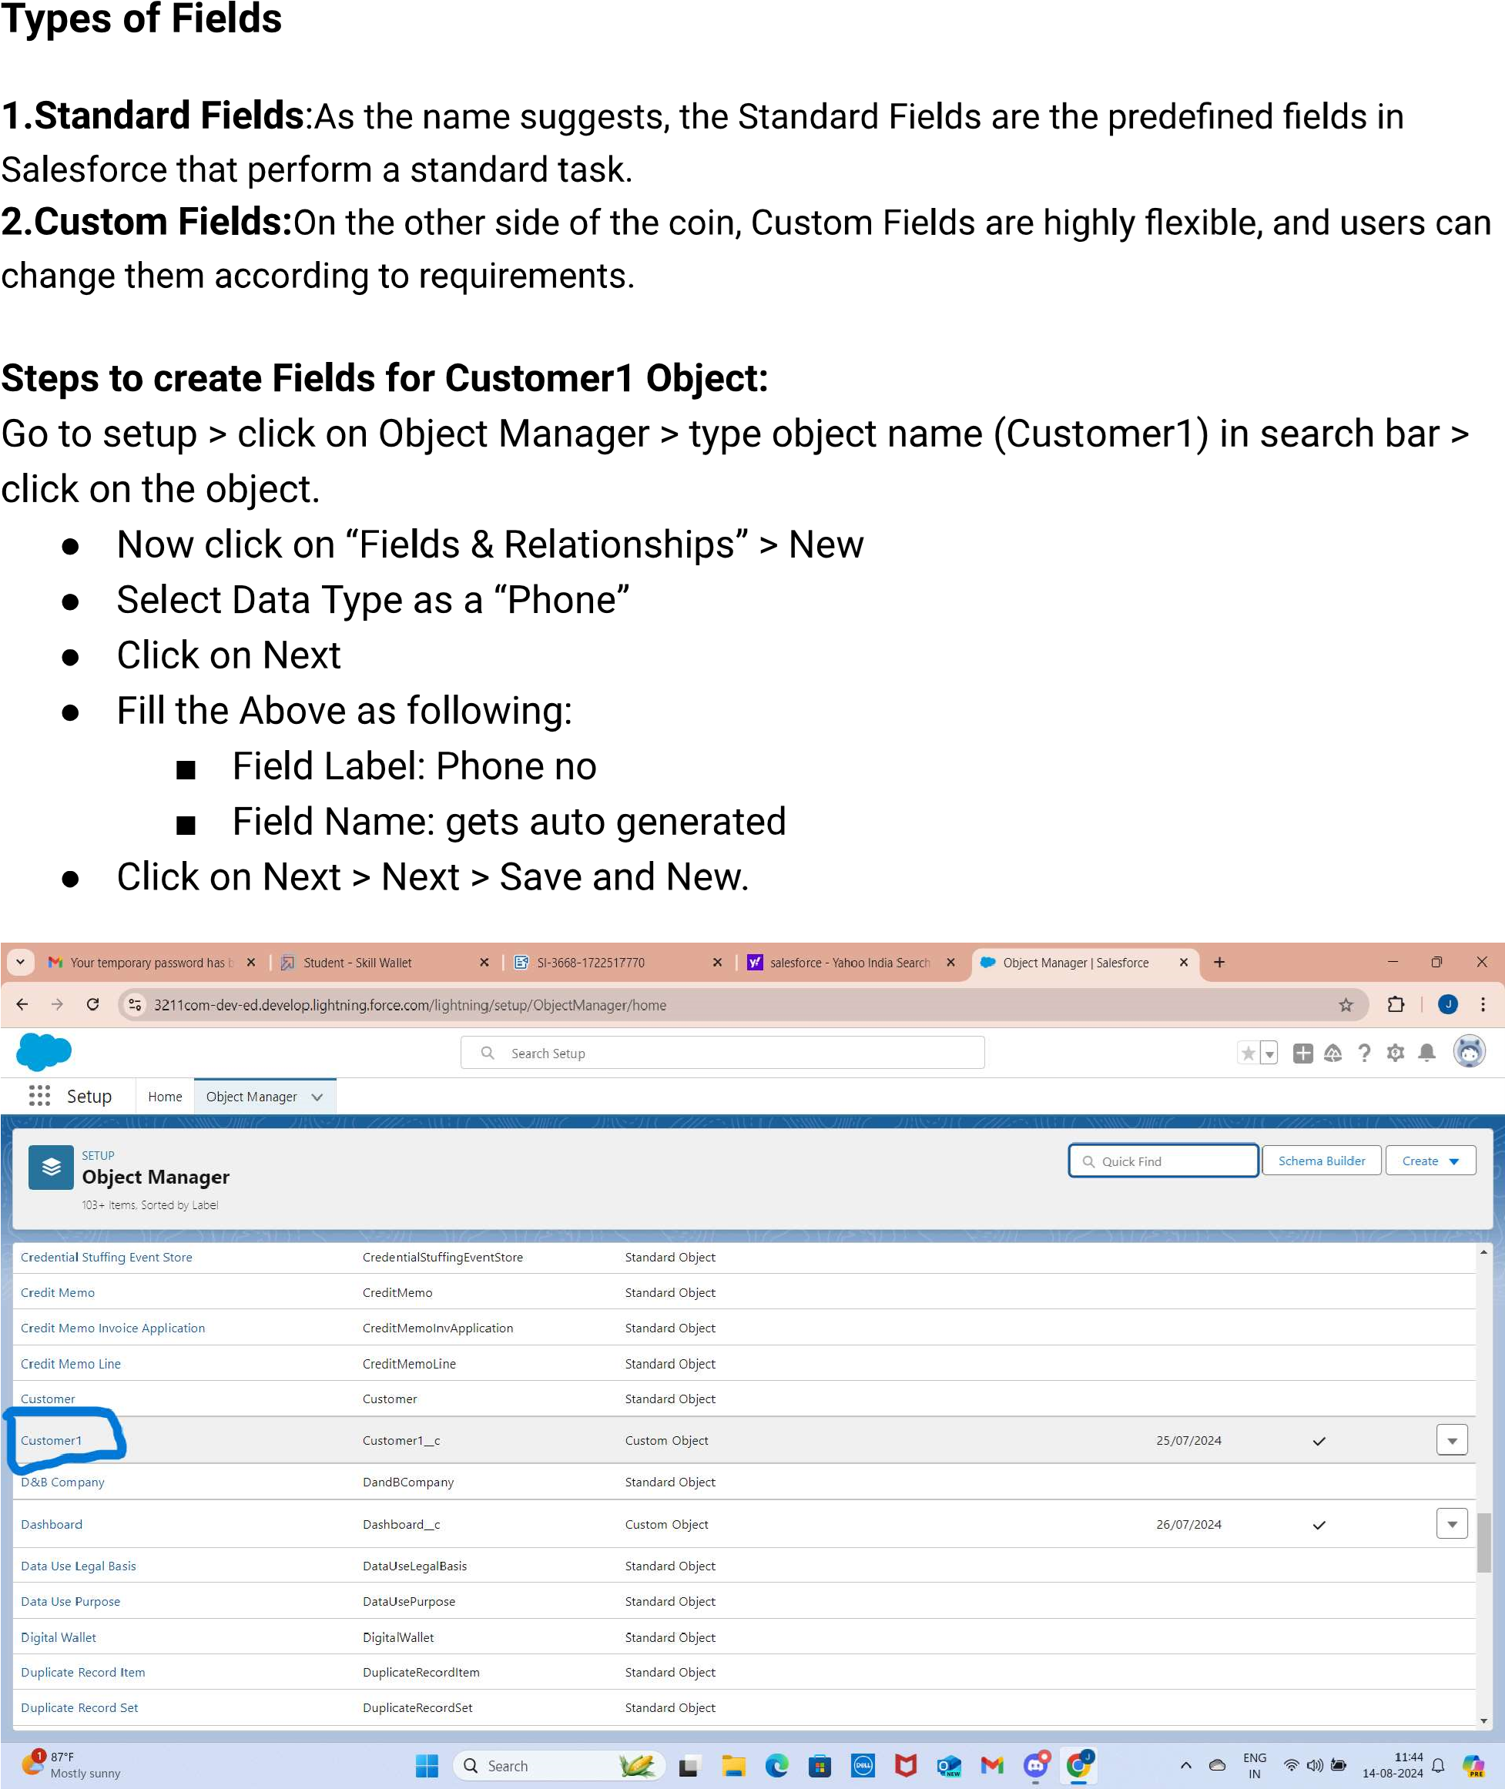

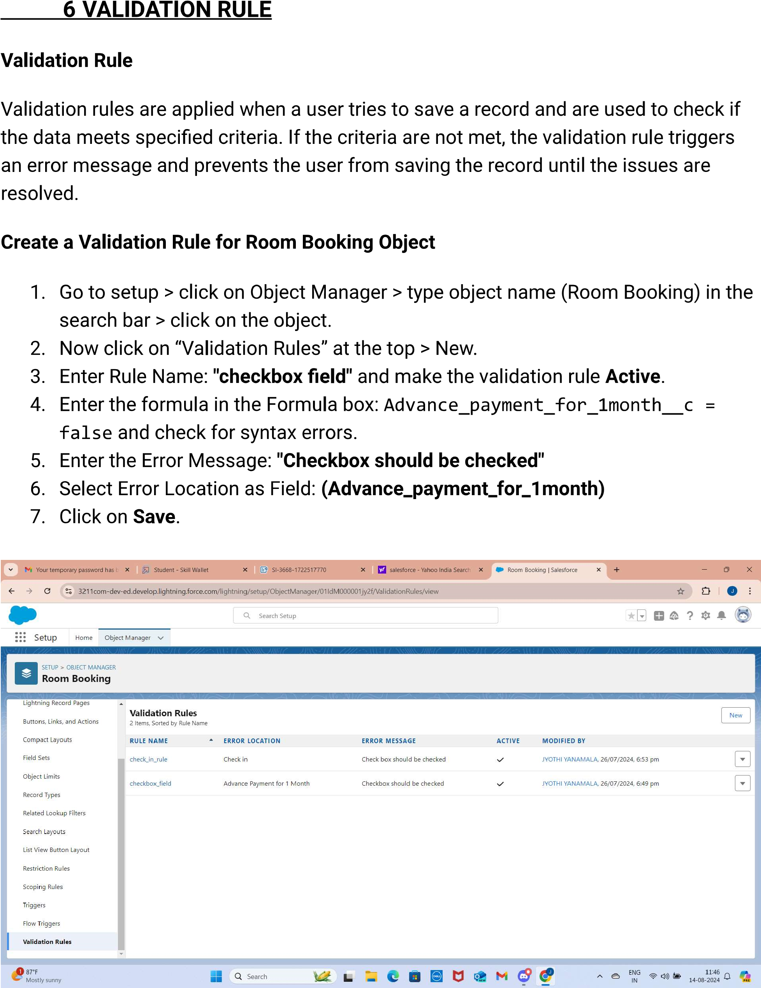

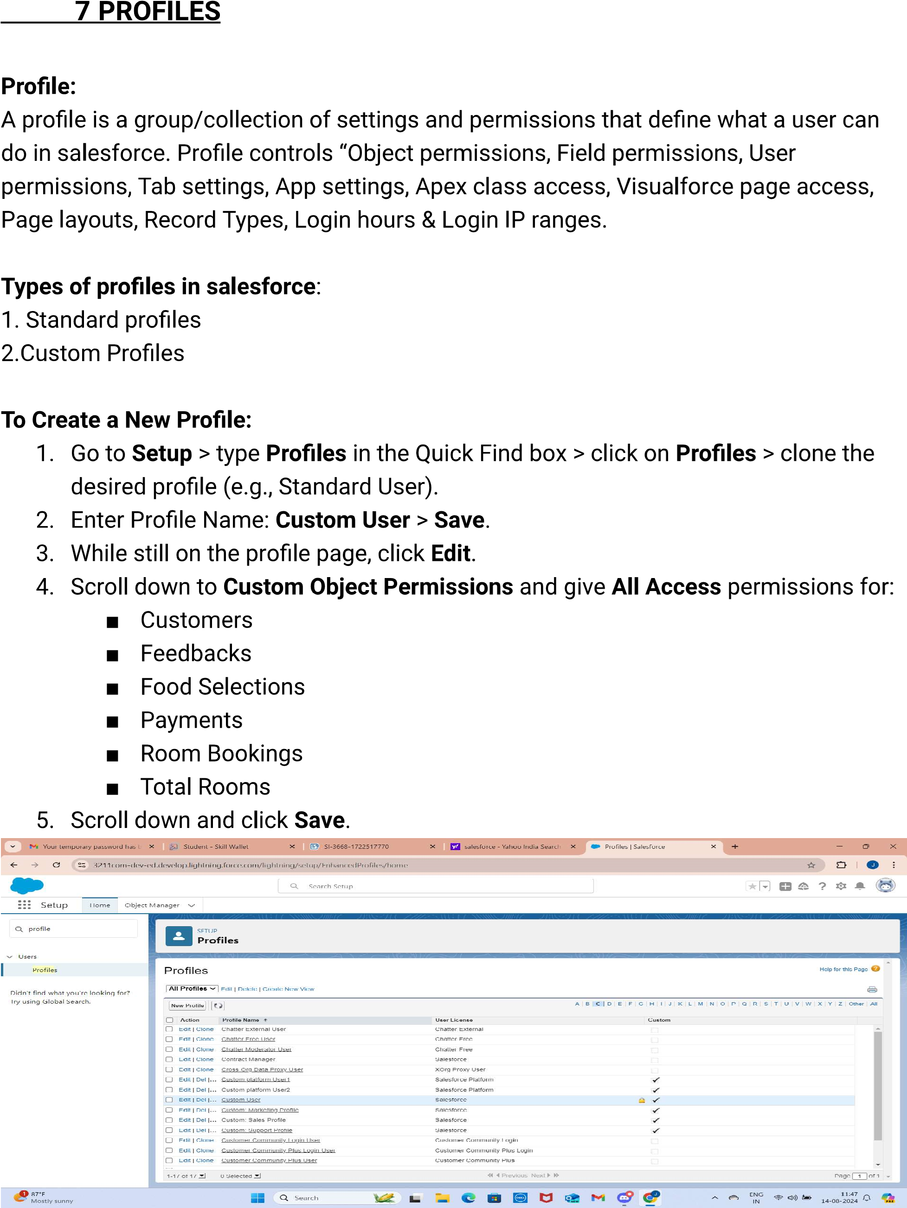

1. **ROLES**

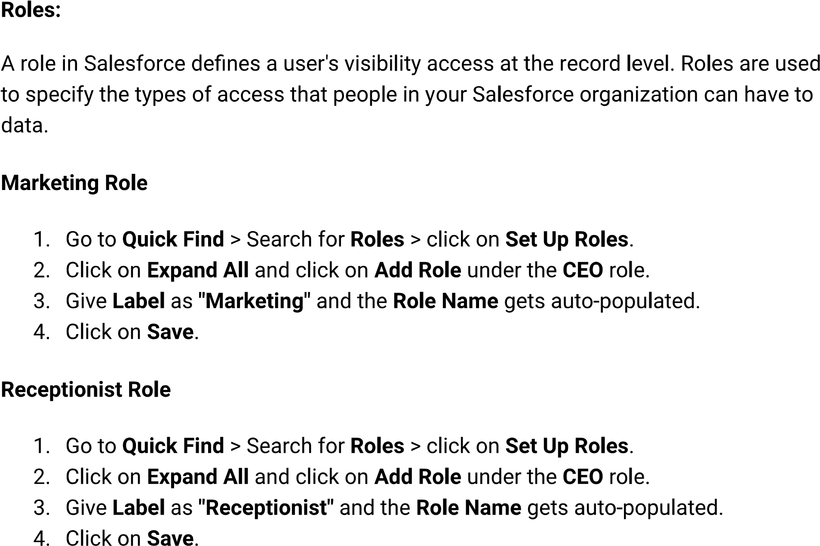

1. **USERS**

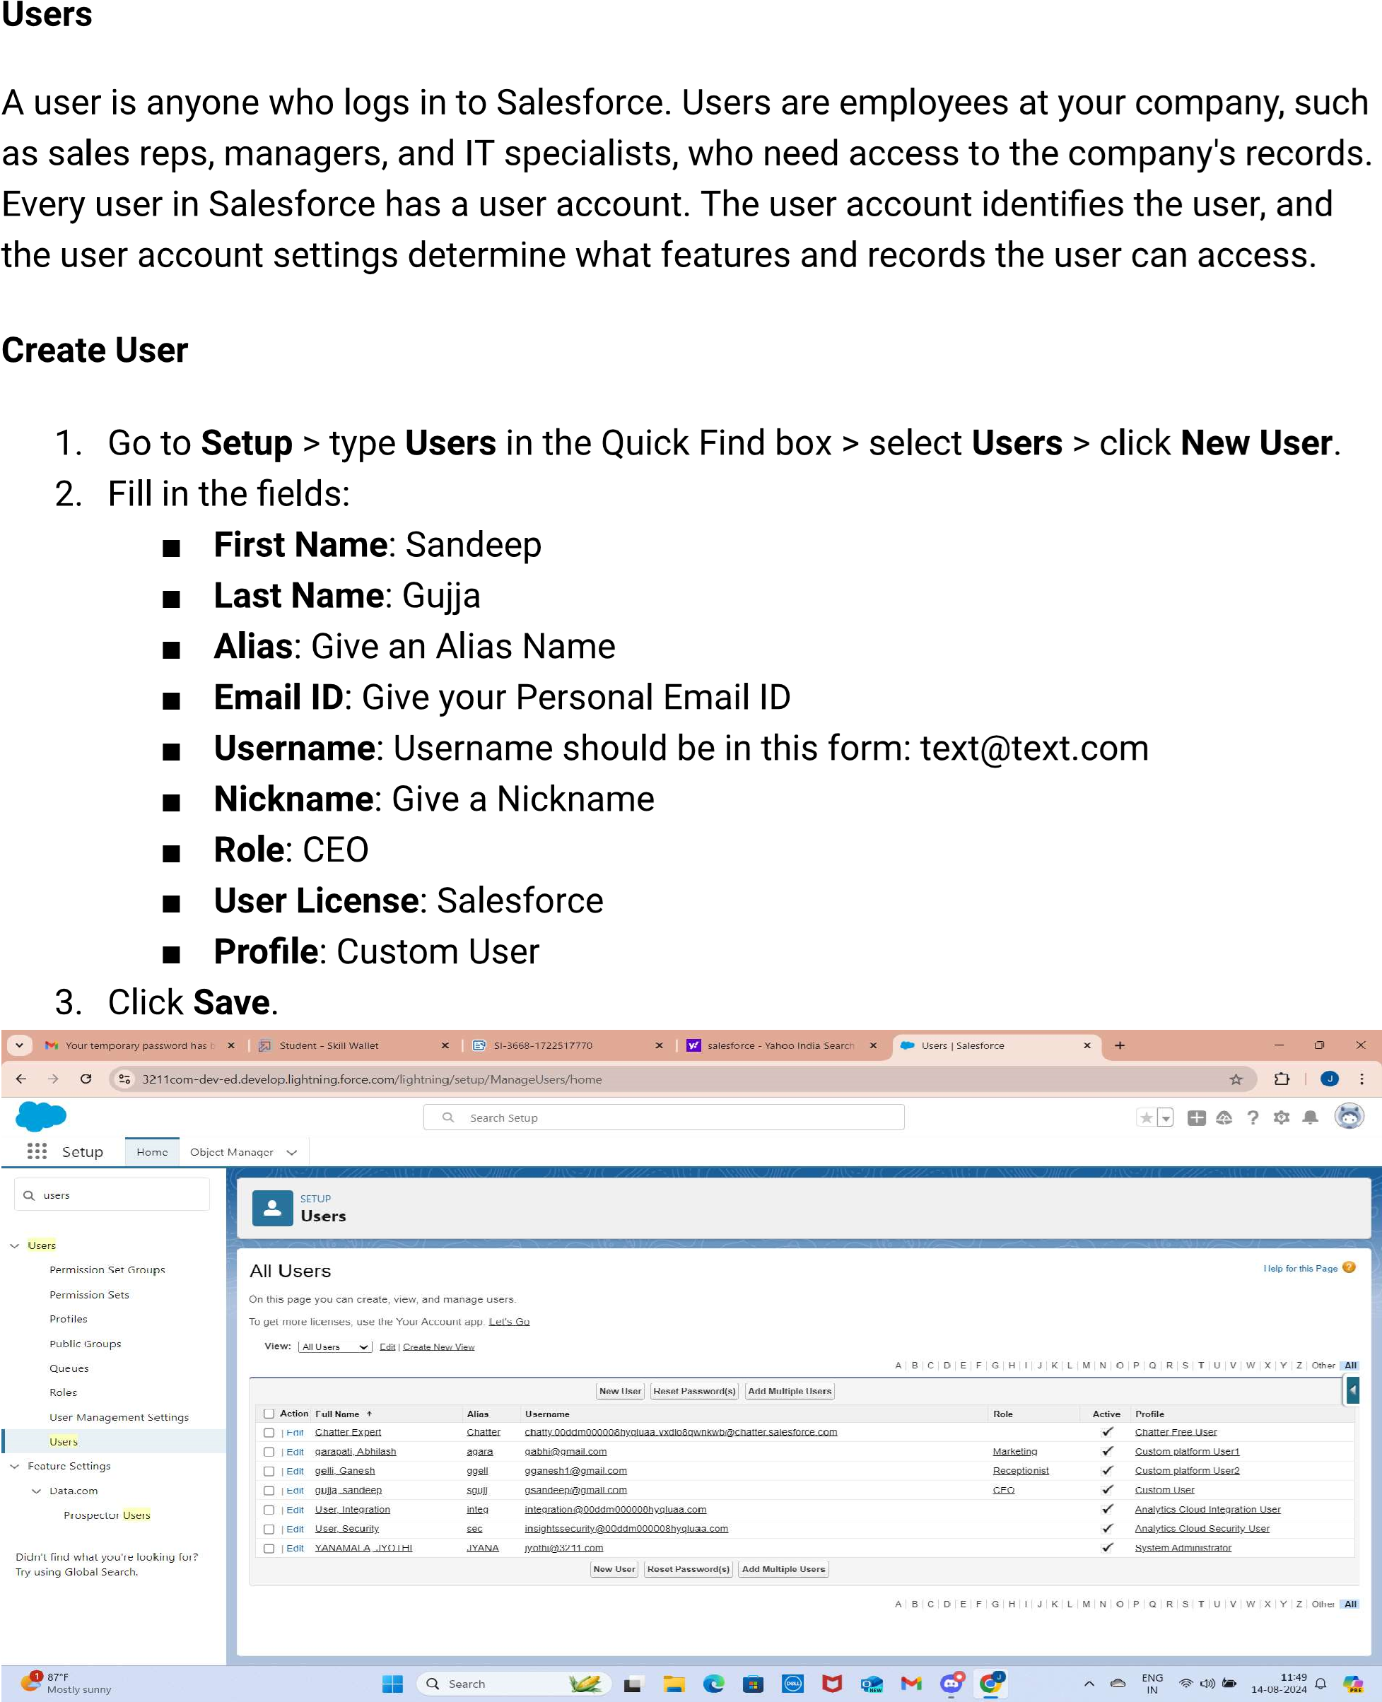

1. **USER ADOPTION**

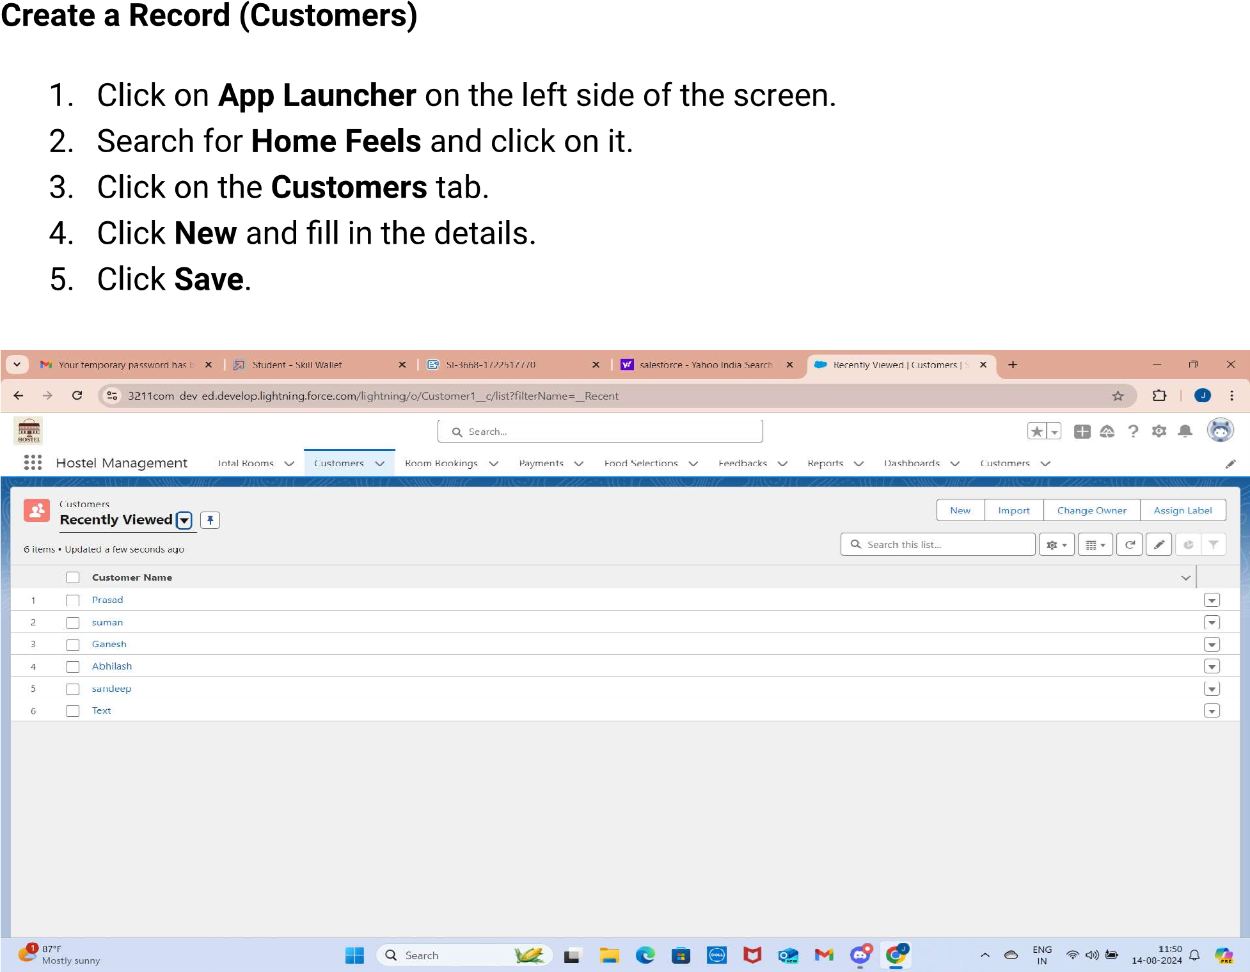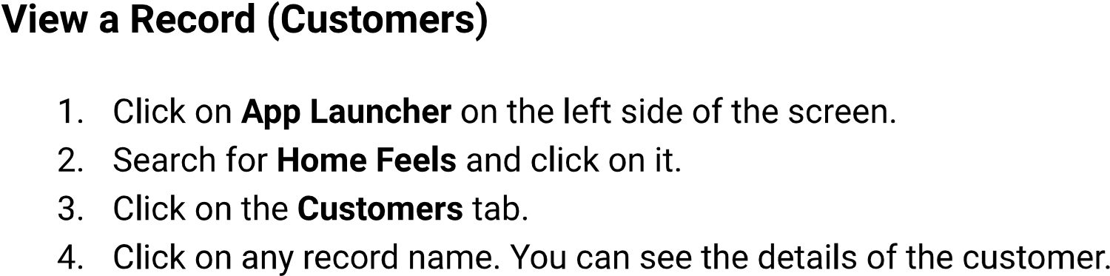

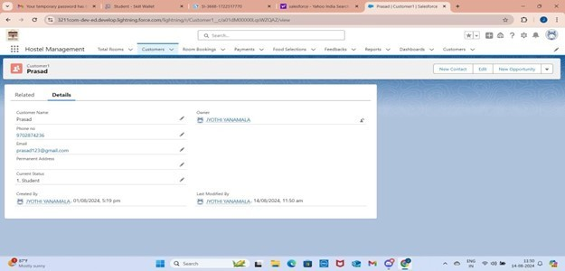

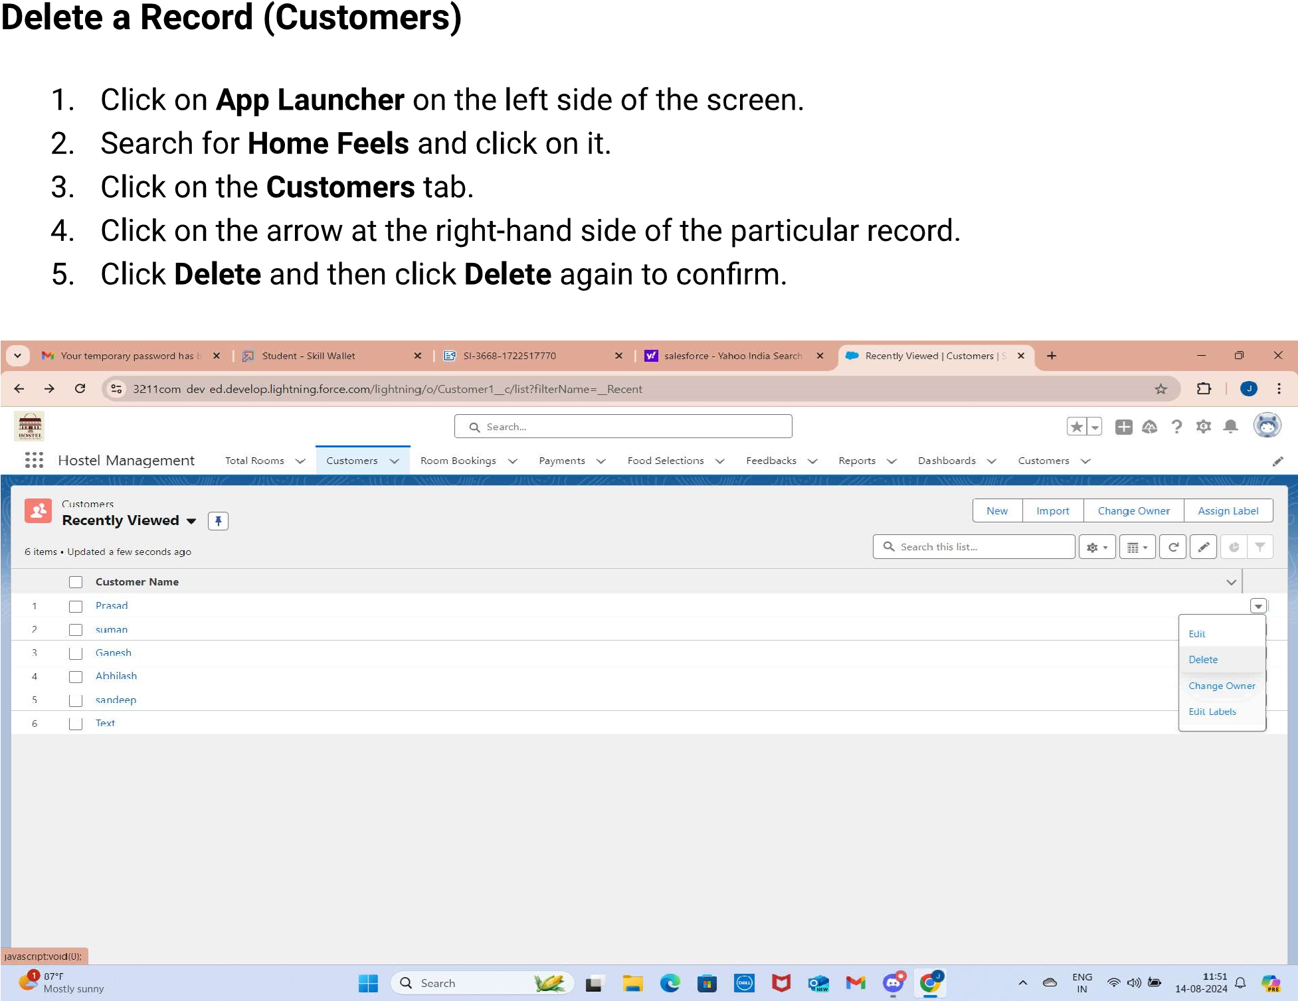

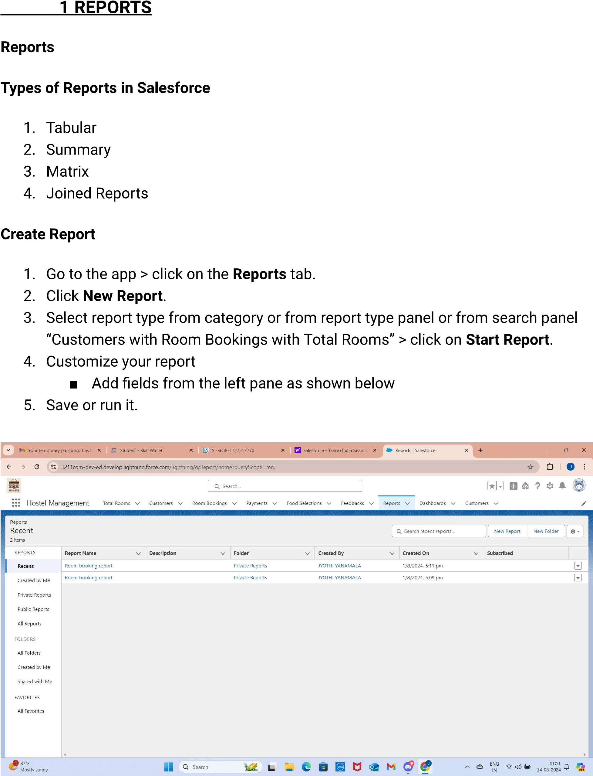

2.DASHBOARDS

